UNIT-III:

Decision Table
A Decision Table is a tabular representation of inputs versus rules/cases/test conditions. It is a very effective tool used for both complex requirements management and software testing. Decision table helps to check all possible combinations of conditions for testing and testers can also identify missed conditions easily. The conditions are indicated as True(T) and False(F) values.
The condition is simple if the user provides correct username and password the user will be redirected to the homepage. If any of the input is wrong, an error message will be displayed.
Conditions | Rule 1 | Rule 2 | Rule 3 | Rule 4
Username (T/F) | F | T | F | T
Password (T/F) | F | F | T | T
Output (E/H) | E | E | E | H
Legend:
- T – Correct username/password
- F – Wrong username/password
- E – Error message is displayed
- H – Home screen is displayed

Example 2: How to make Decision Table for Upload Screen
Now consider a dialogue box which will ask the user to upload photo with certain conditions like –
- You can upload only '.jpg' format image
- file size less than 32kb
- resolution 137*177.
If any of the conditions fails the system will throw corresponding error message stating the issue and if all conditions are met photo will be updated successfully
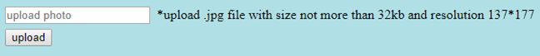
Let's create the decision table for this case.
Conditions | Case 1 | Case 2 | Case 3 | Case 4 | Case 5 | Case 6 | Case 7 | Case 8
Format | .jpg | .jpg | .jpg | .jpg | Not .jpg | Not .jpg | Not .jpg | Not .jpg
Size | Less than 32kb | Less than 32kb | >= 32kb | >= 32kb | Less than 32kb | Less than 32kb | >= 32kb | >= 32kb
resolution | 137*177 | Not 137*177 | 137*177 | Not 137*177 | 137*177 | Not 137*177 | 137*177 | Not 137*177
Output | Photo uploaded | Error message resolution mismatch | Error message size mismatch | Error message size and resolution mismatch | Error message for format mismatch | Error message format and resolution mismatch | Error message for format and size mismatch

Advantages of Decision Table Testing
- When the system behavior is different for different input and not same for a range of inputs, both equivalent partitioning, and boundary value analysis won't help, but decision table can be used.
- The representation is simple so that it can be easily interpreted and is used for development and business as well.
- This table will help to make effective combinations and can ensure a better coverage for testing
- Any complex business conditions can be easily turned into decision tables
- In a case we are going for 100% coverage typically when the input combinations are low, this technique can ensure the coverage.

EVENT TABLE
Event tables are used to model the behavior of a system in response to events. Events trigger transitions between different states in a system.
Building UML diagrams is a very important and time consuming task for both requirements and design phases. However, some of these diagrams, such as use-case and class diagrams can be considered as a transition between the two phases. Approach: Through this study, the event table will be used to derive the use-case and class diag...
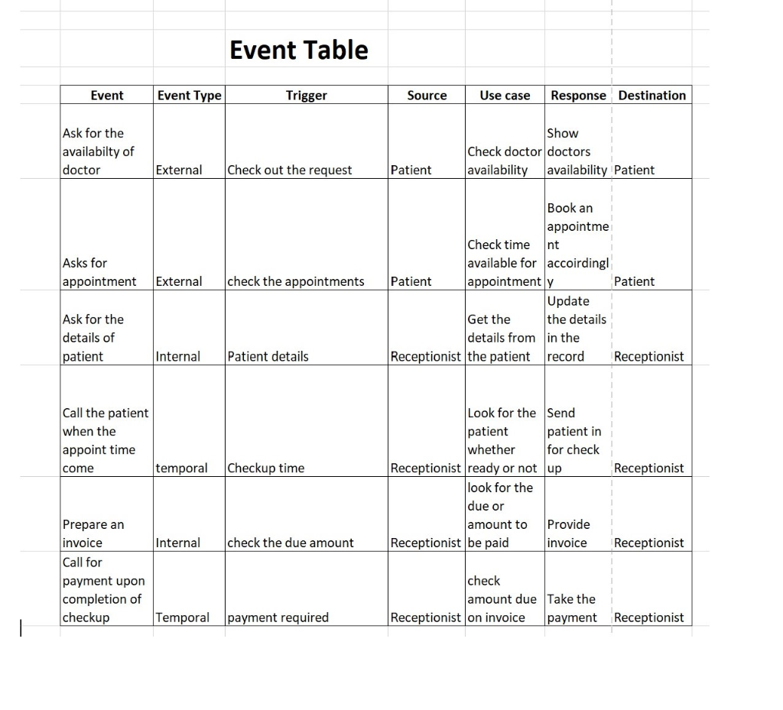

Example-of- event table -mapping-a-use-case-and-actor
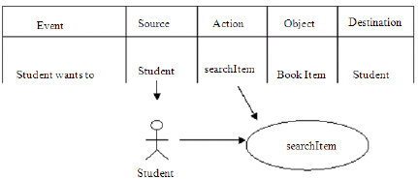
Example-of-event table -mapping-class-notation
